1. Partial Class
A partial class allows one class to be divided into multiple files using the partial keyword. It is useful when a class becomes too large.
In my project, I first created BookingController.cs with all booking related APIs in one file. It included seat locking, booking creation, payment validation, ticket generation, and booking history methods.
At beginning it was okay, but after adding more APIs the file became too lengthy and harder to manage.
So later I understood partial class could improve code structure.

Before:
Single file:
File:
Controllers/BookingController.cs
All booking logic was inside one controller.(400 Lines of code)
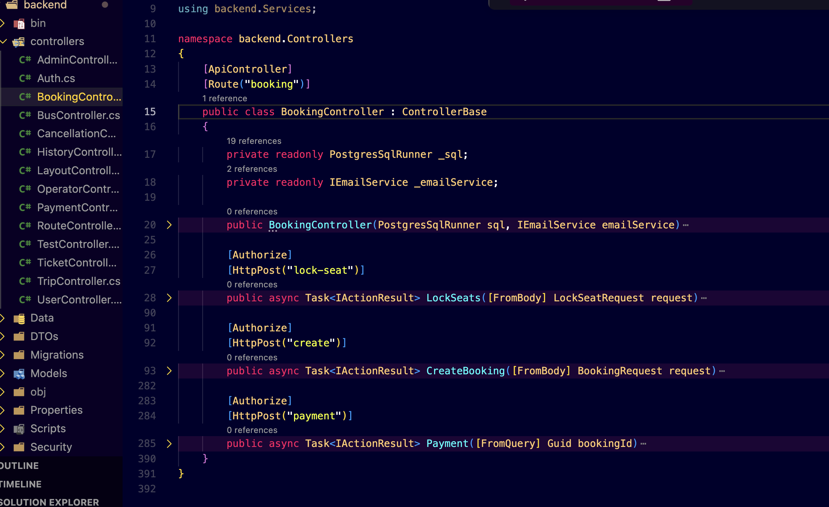

After:
Split into smaller files:
Controllers/
├── BookingController.Seat.cs
├── BookingController.Payment.cs
├── BookingController.Booking.cs

Example:
File: BookingController.Seat.cs
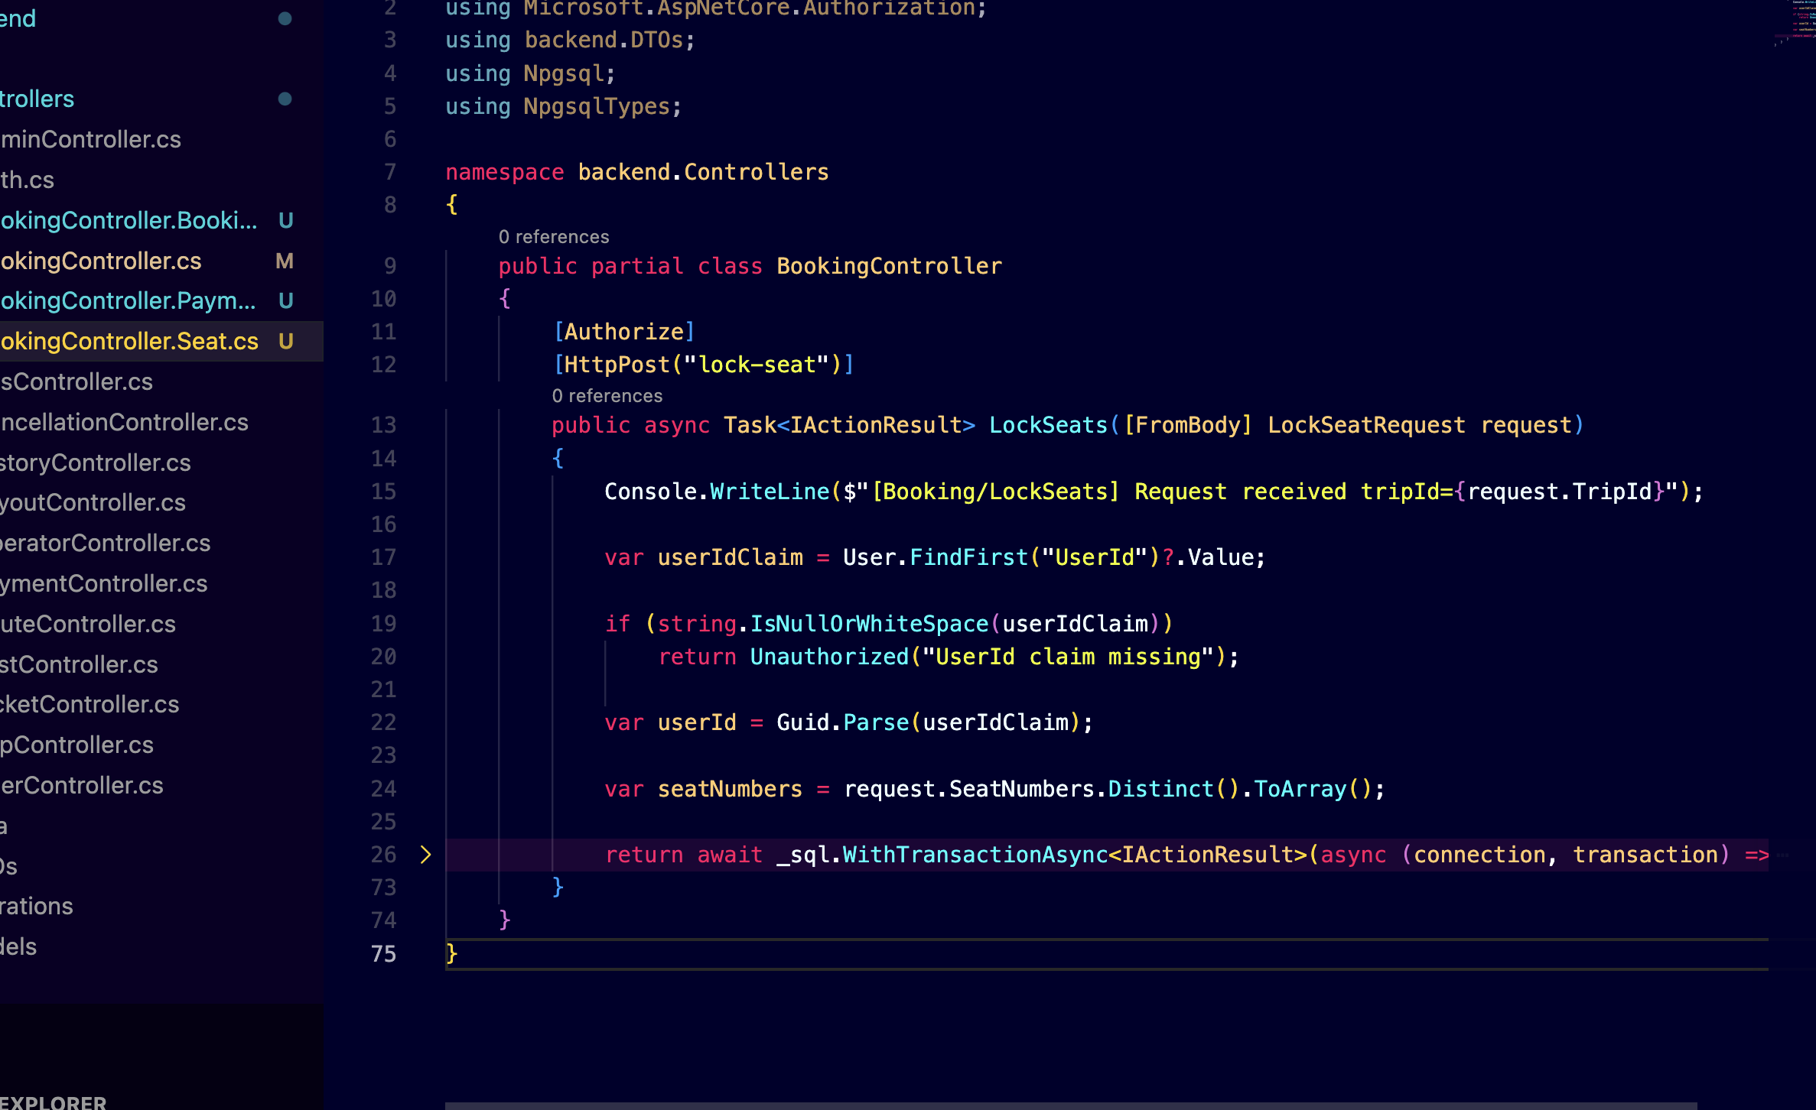
File: BookingController.Payment.cs
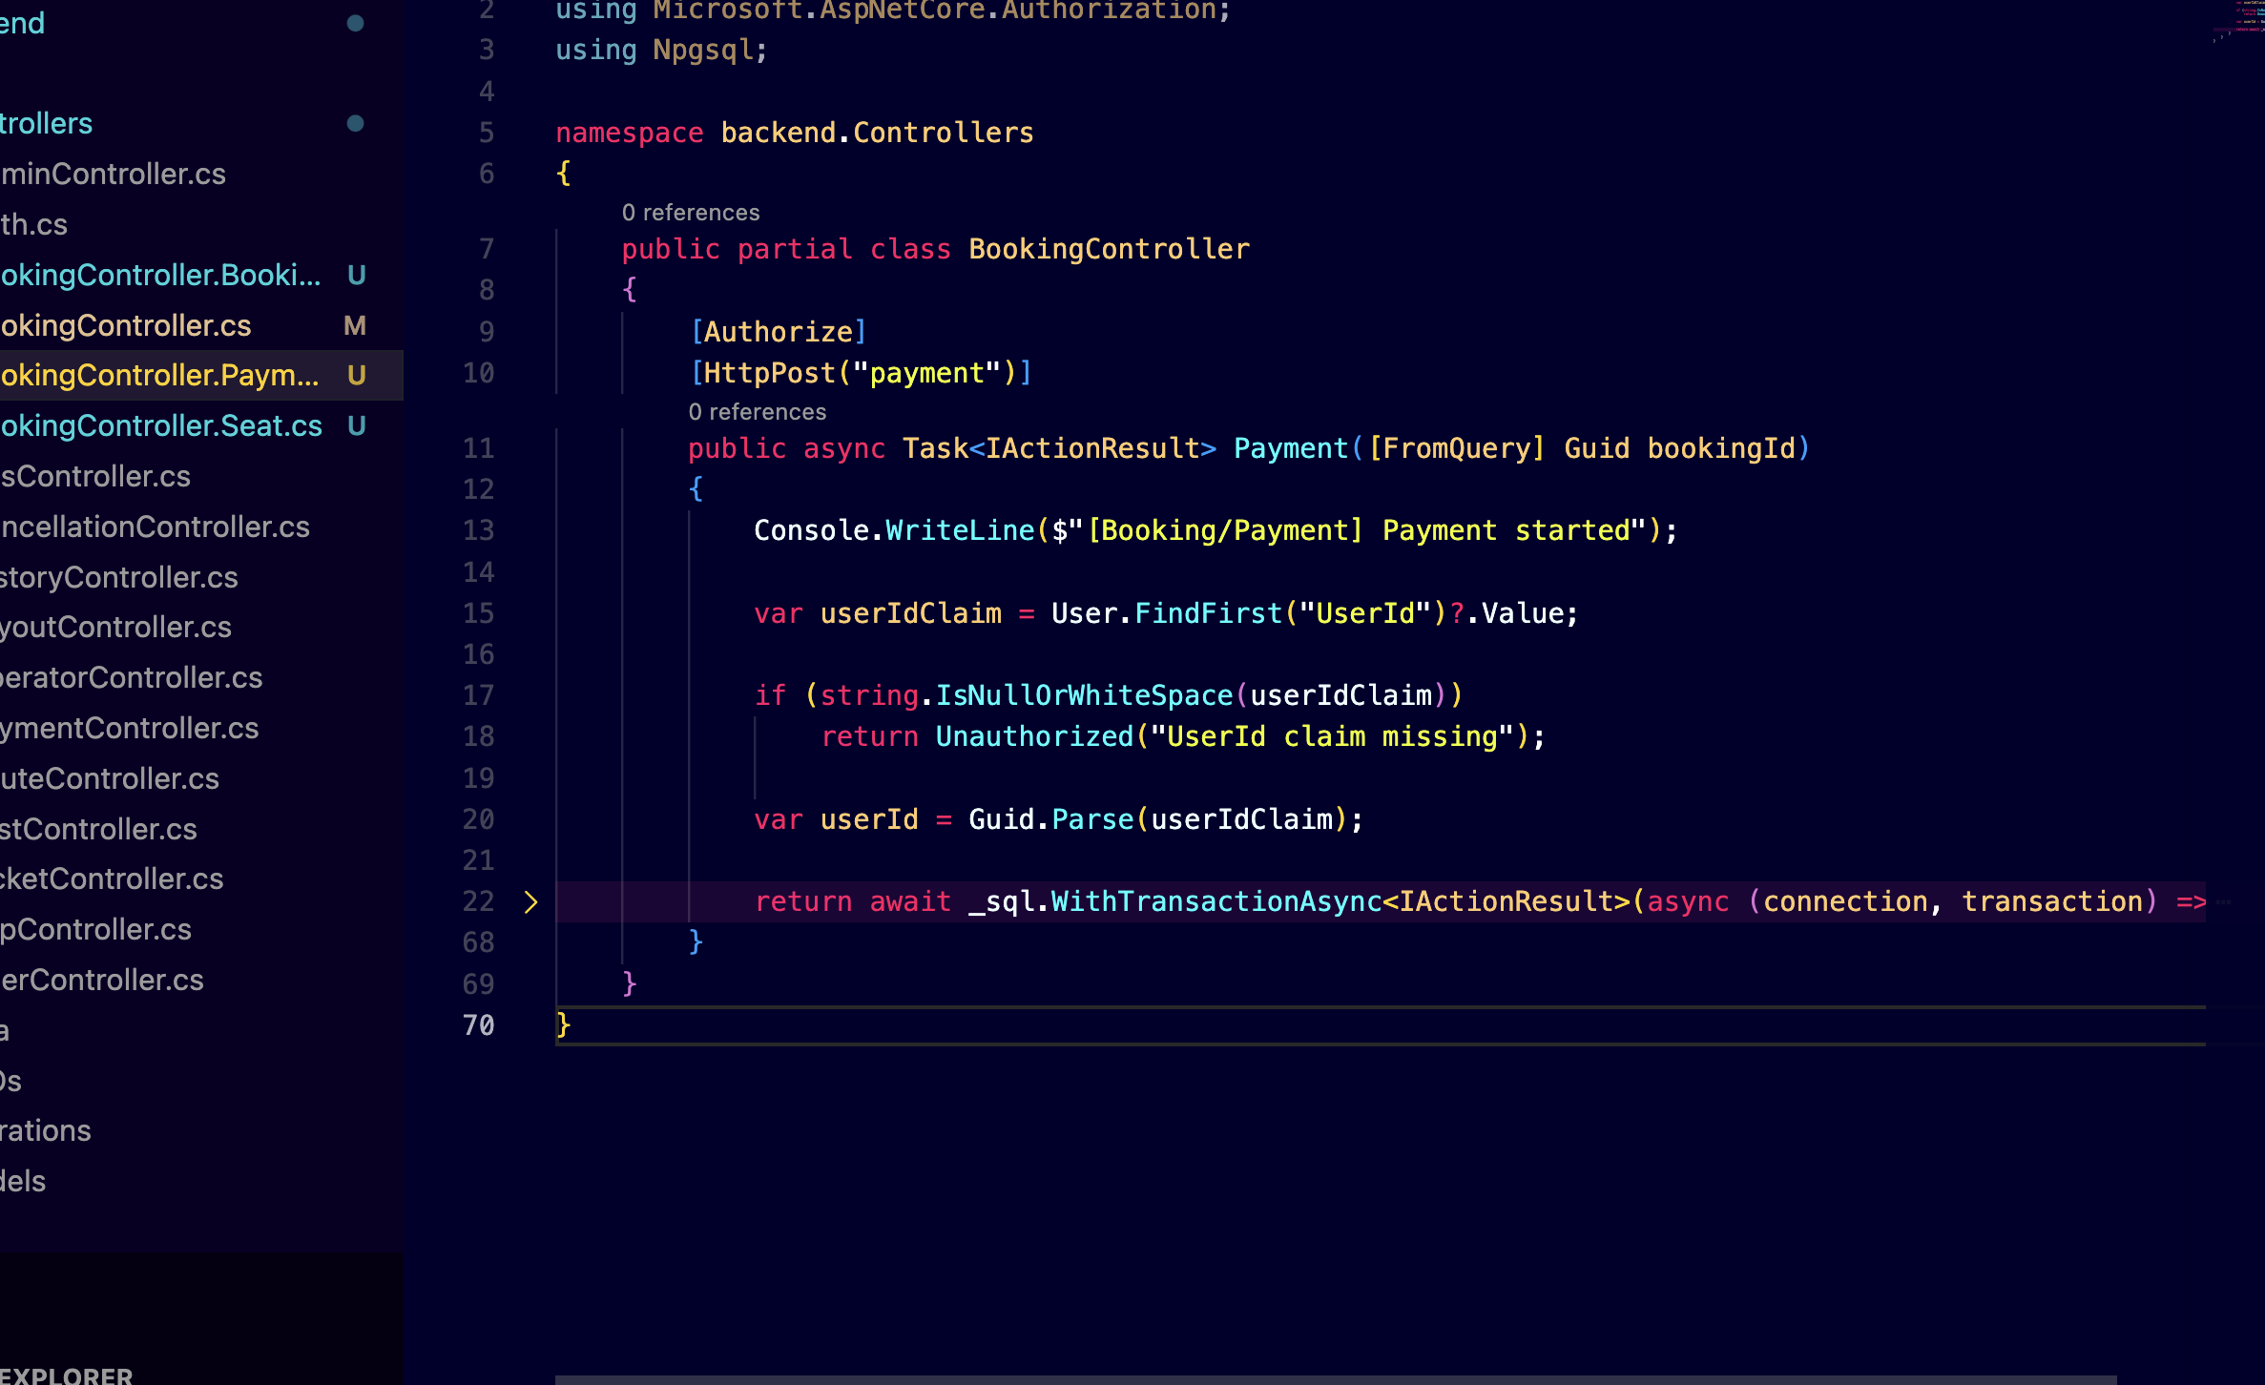
File: BookingController.Booking.cs
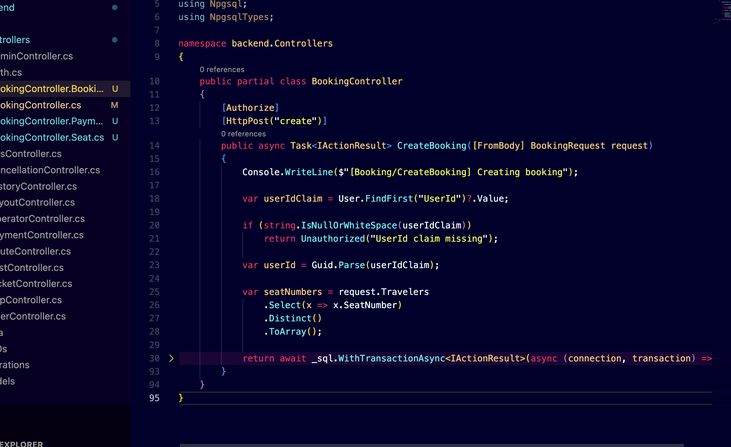

2. Abstract Class
Abstract class helps when multiple classes share common behavior but implementation can be different.
In my project, notification system was one good place to use this.
Whenever booking gets confirmed or cancelled, system sends notifications.

Files:
Before:
Notification code was directly written in service classes.
After:
Created base abstraction.
File:
Services/MessageService.cs
public abstract class MessageService
{
public abstract void SendMessage(string content);

public void SaveLogs()
{
Console.WriteLine("Message logged");
}
}
Derived class:
File:
Services/SmsService.cs
public class SmsService : MessageService
{
public override void SendMessage(string content)
{
Console.WriteLine("SMS sent: " + content);
}
}

3. Generic Class
Generic classes helped me reduce repeated code.
In my project, many APIs returned same structure:
- success status
- response message
- actual data
Instead of creating many response classes, I used one generic model.

Before:
Files like:
BusResult.cs
RouteResult.cs
UserResult.cs

After:
File:
Common/ResultModel.cs
public class ResultModel<T>
{
public bool Success { get; set; }
public string Message { get; set; }
public T Result { get; set; }
}
Usage:
var response = new ResultModel<User>()
{
Success = true,
Message = "User fetched",
Result = user
};

4. Repository Pattern
Repository pattern helped separate database code from controllers.
At first, I wrote SQL queries directly inside TripController.cs.
It worked, but controller became crowded.
Later I moved DB logic into repository classes.

Before:
File:
Controllers/TripController.cs
Database logic inside controller.
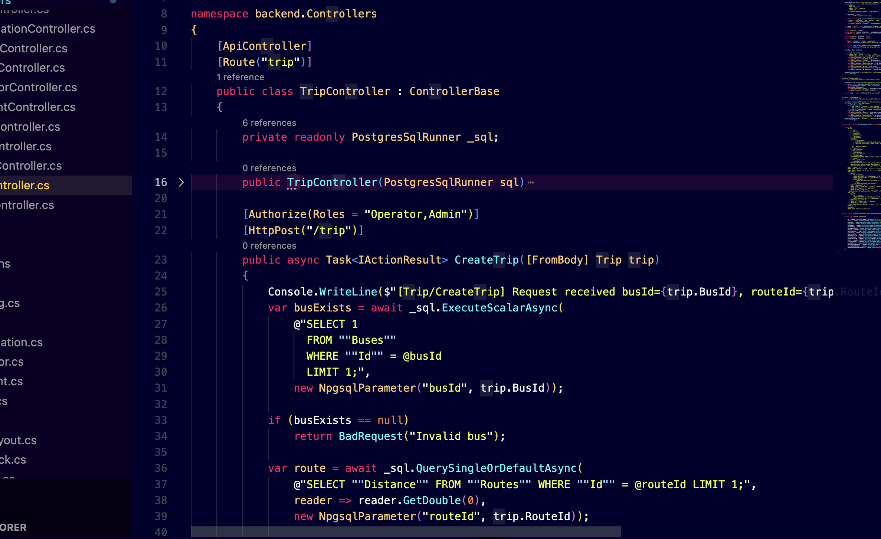

After:
Files:
Controllers/TripController.cs
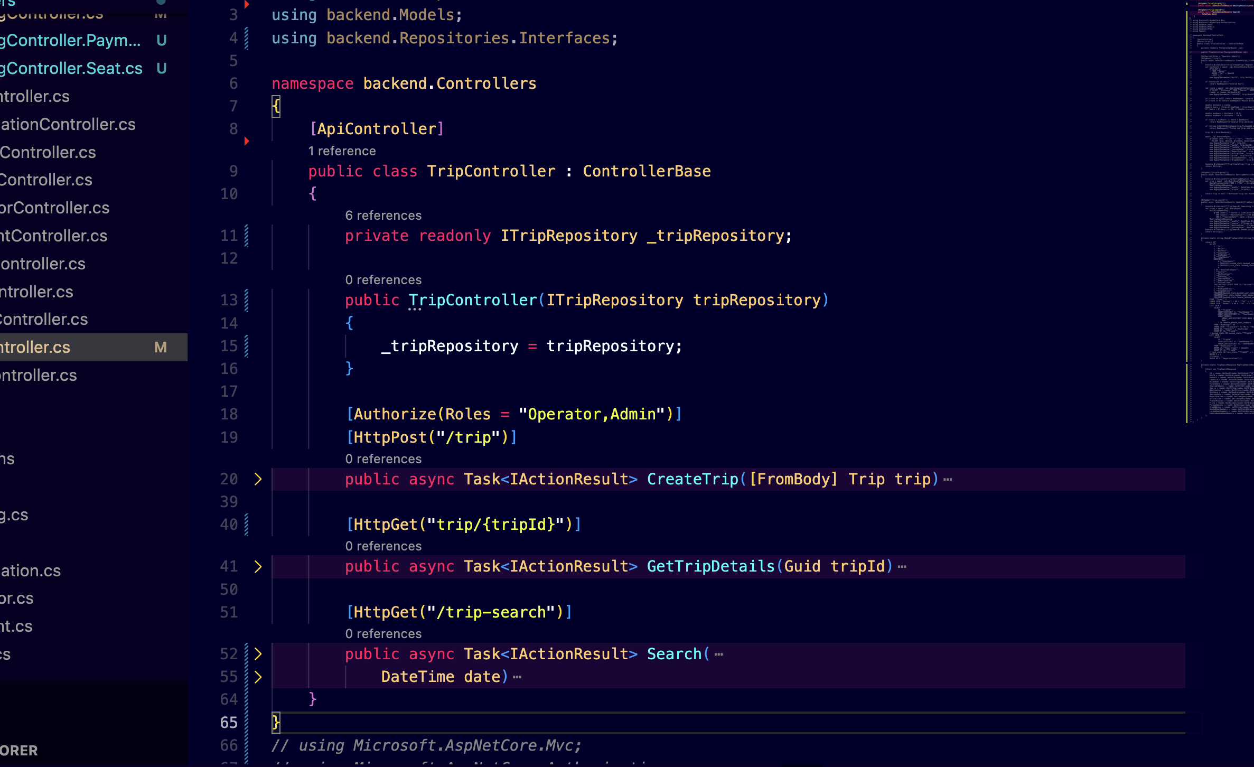

Repositories/Interfaces/ITripRepository.cs

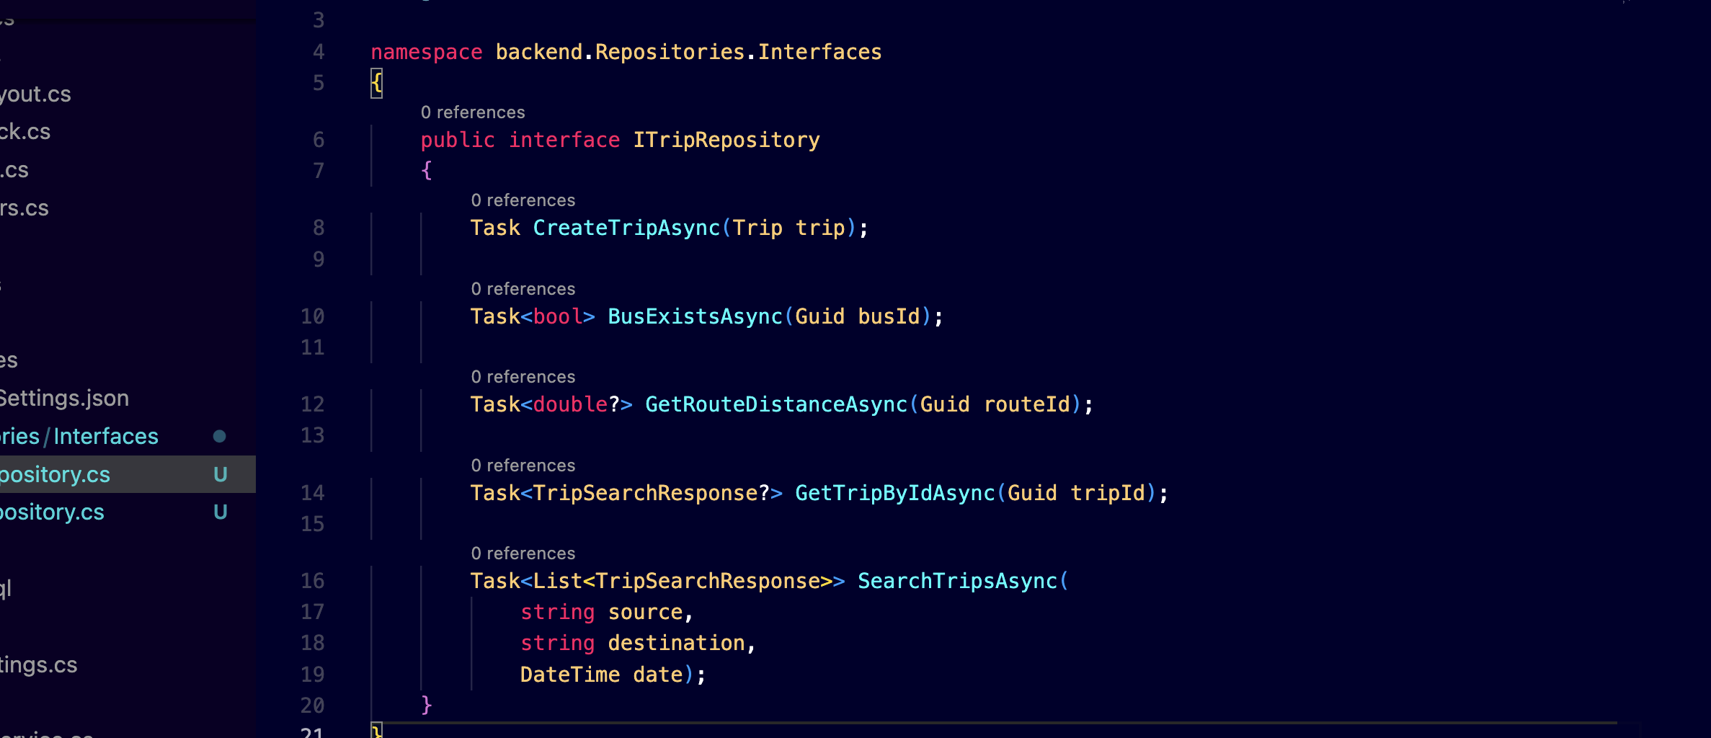

Repositories/TripRepository.cs

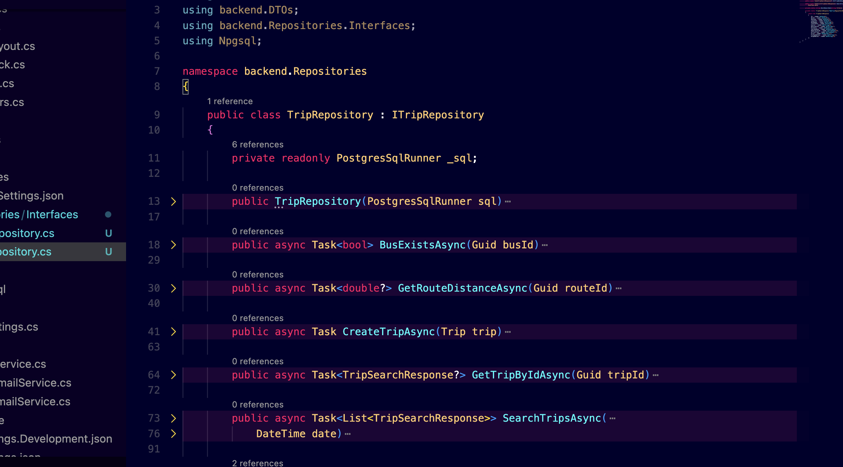

5. Model Preparation
Model design was very important because all modules were connected.
Entities included:
- Customer
- Bus
- Route
- Journey
- Reservation
- Passenger
Initially some models had extra unnecessary fields, and some DTOs were mixed with entities.
Later I organized them properly.

Before:
Mixed classes inside one folder.

After:
Models/
DTOs/
ViewModels/

Example:
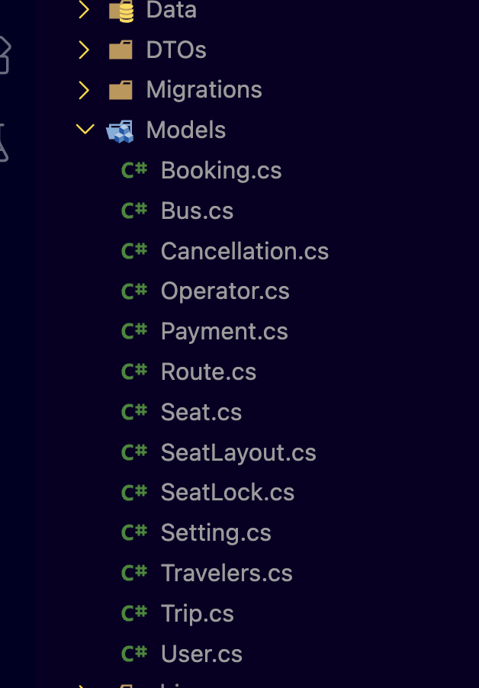

6. Interface (Extra Design Improvement)
Interfaces helped in dependency injection.
Example in payment service.

Files:
Services/IPaymentGateway.cs
Services/DummyPaymentGateway.cs

Example:
public interface IPaymentGateway
{
bool Process(decimal amount);
}
public class DummyPaymentGateway : IPaymentGateway
{
public bool Process(decimal amount)
{
return true;
}
}

